|  |
| --- |
| EPAM Systems, RD Dep. |
| MTN.BI.07 Oracle Relational Structures Report |

|  |  |  |  |  |  |
| --- | --- | --- | --- | --- | --- |
| REVISION HISTORY | | | | | |
| Ver. | Description of Change | Author | Date | Approved | |
| Name | Effective Date |
| 1.0 | Initial status | Hanna Hul | 02-NOV-2017 |  |  |

Contents

1. Prerequisite Task 3

2. Heap Organized Tables 3

2.1. Task 1 – Heap Understanding 3

2.2. Task 2 – Understanding Heap Table Segments 4

3. Index Organized Tables 5

3.1. Task 3: Compare performance 5

4. Index Clustered Tables 6

4.1. Task 4: Cluster Storage by Blocks 6

5. Hash Clustered Tables 8

6. Row Migration 8

# Prerequisite Task

Tablespace and a user with the appropriate grants were added.

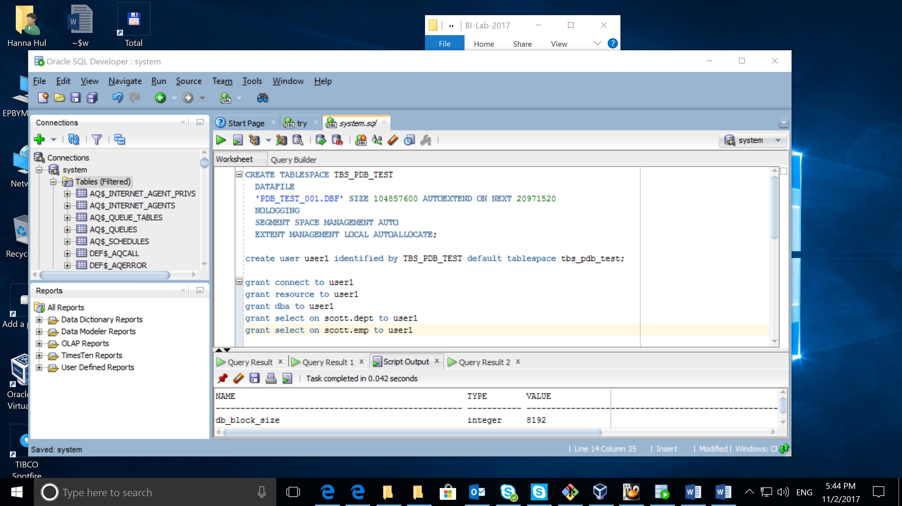

# Heap Organized Tables

## Task 1 – Heap Understanding

Table was created and elements were added.

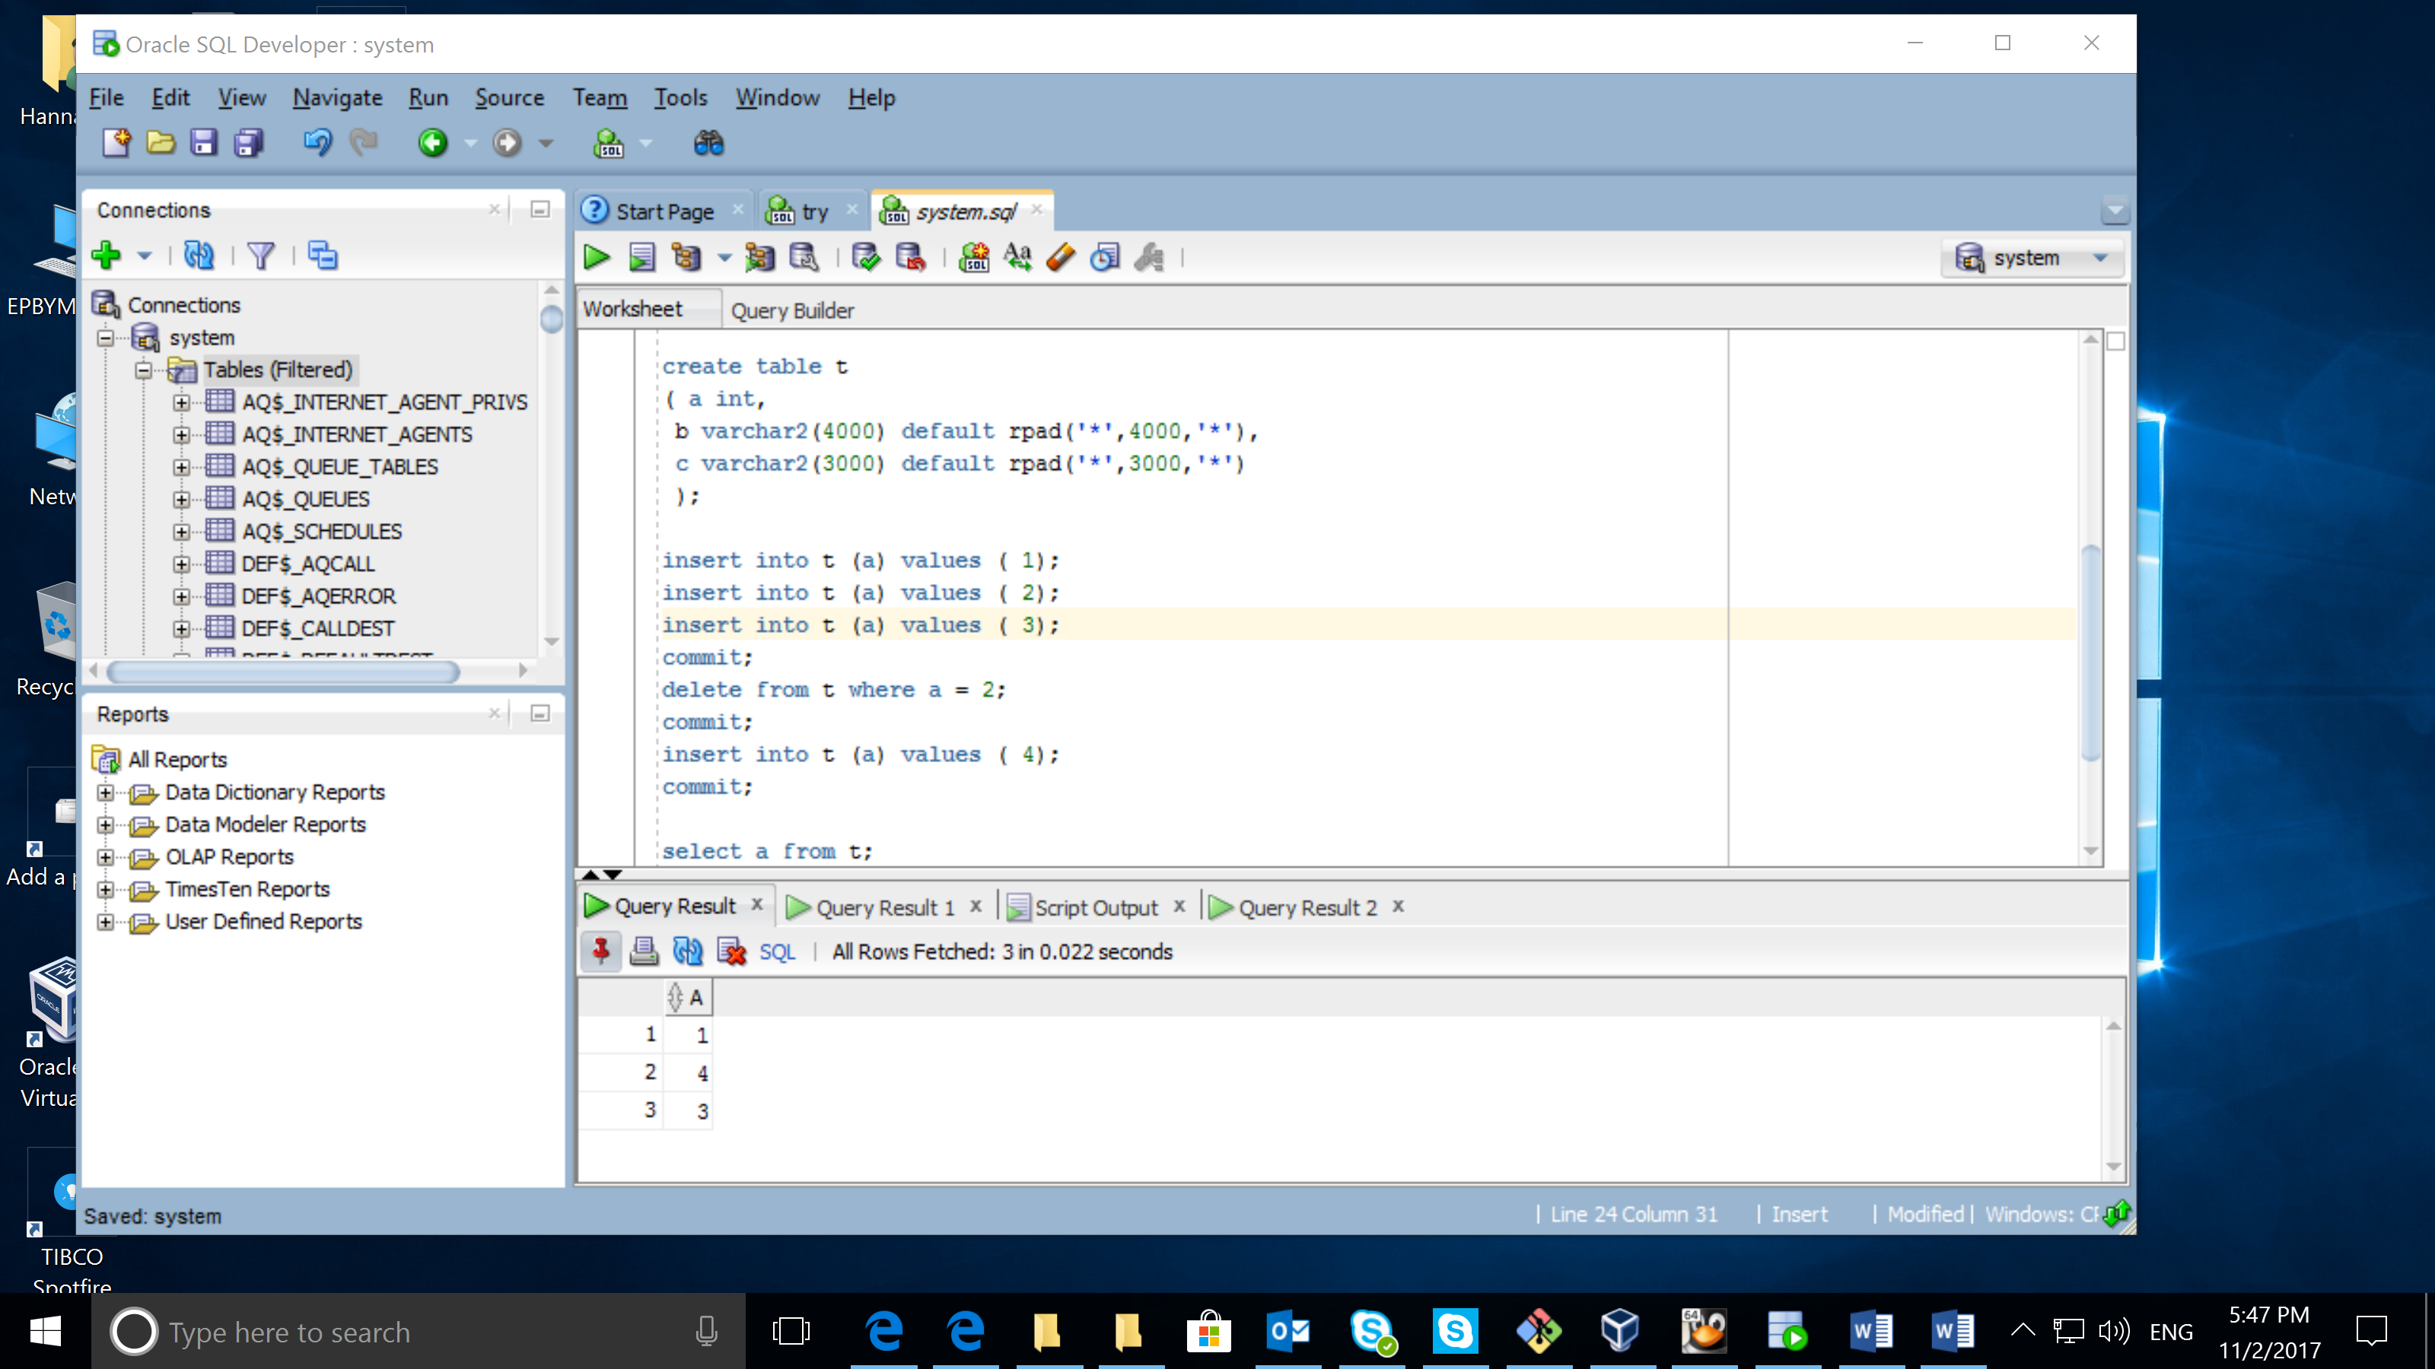

show parameter block_size;

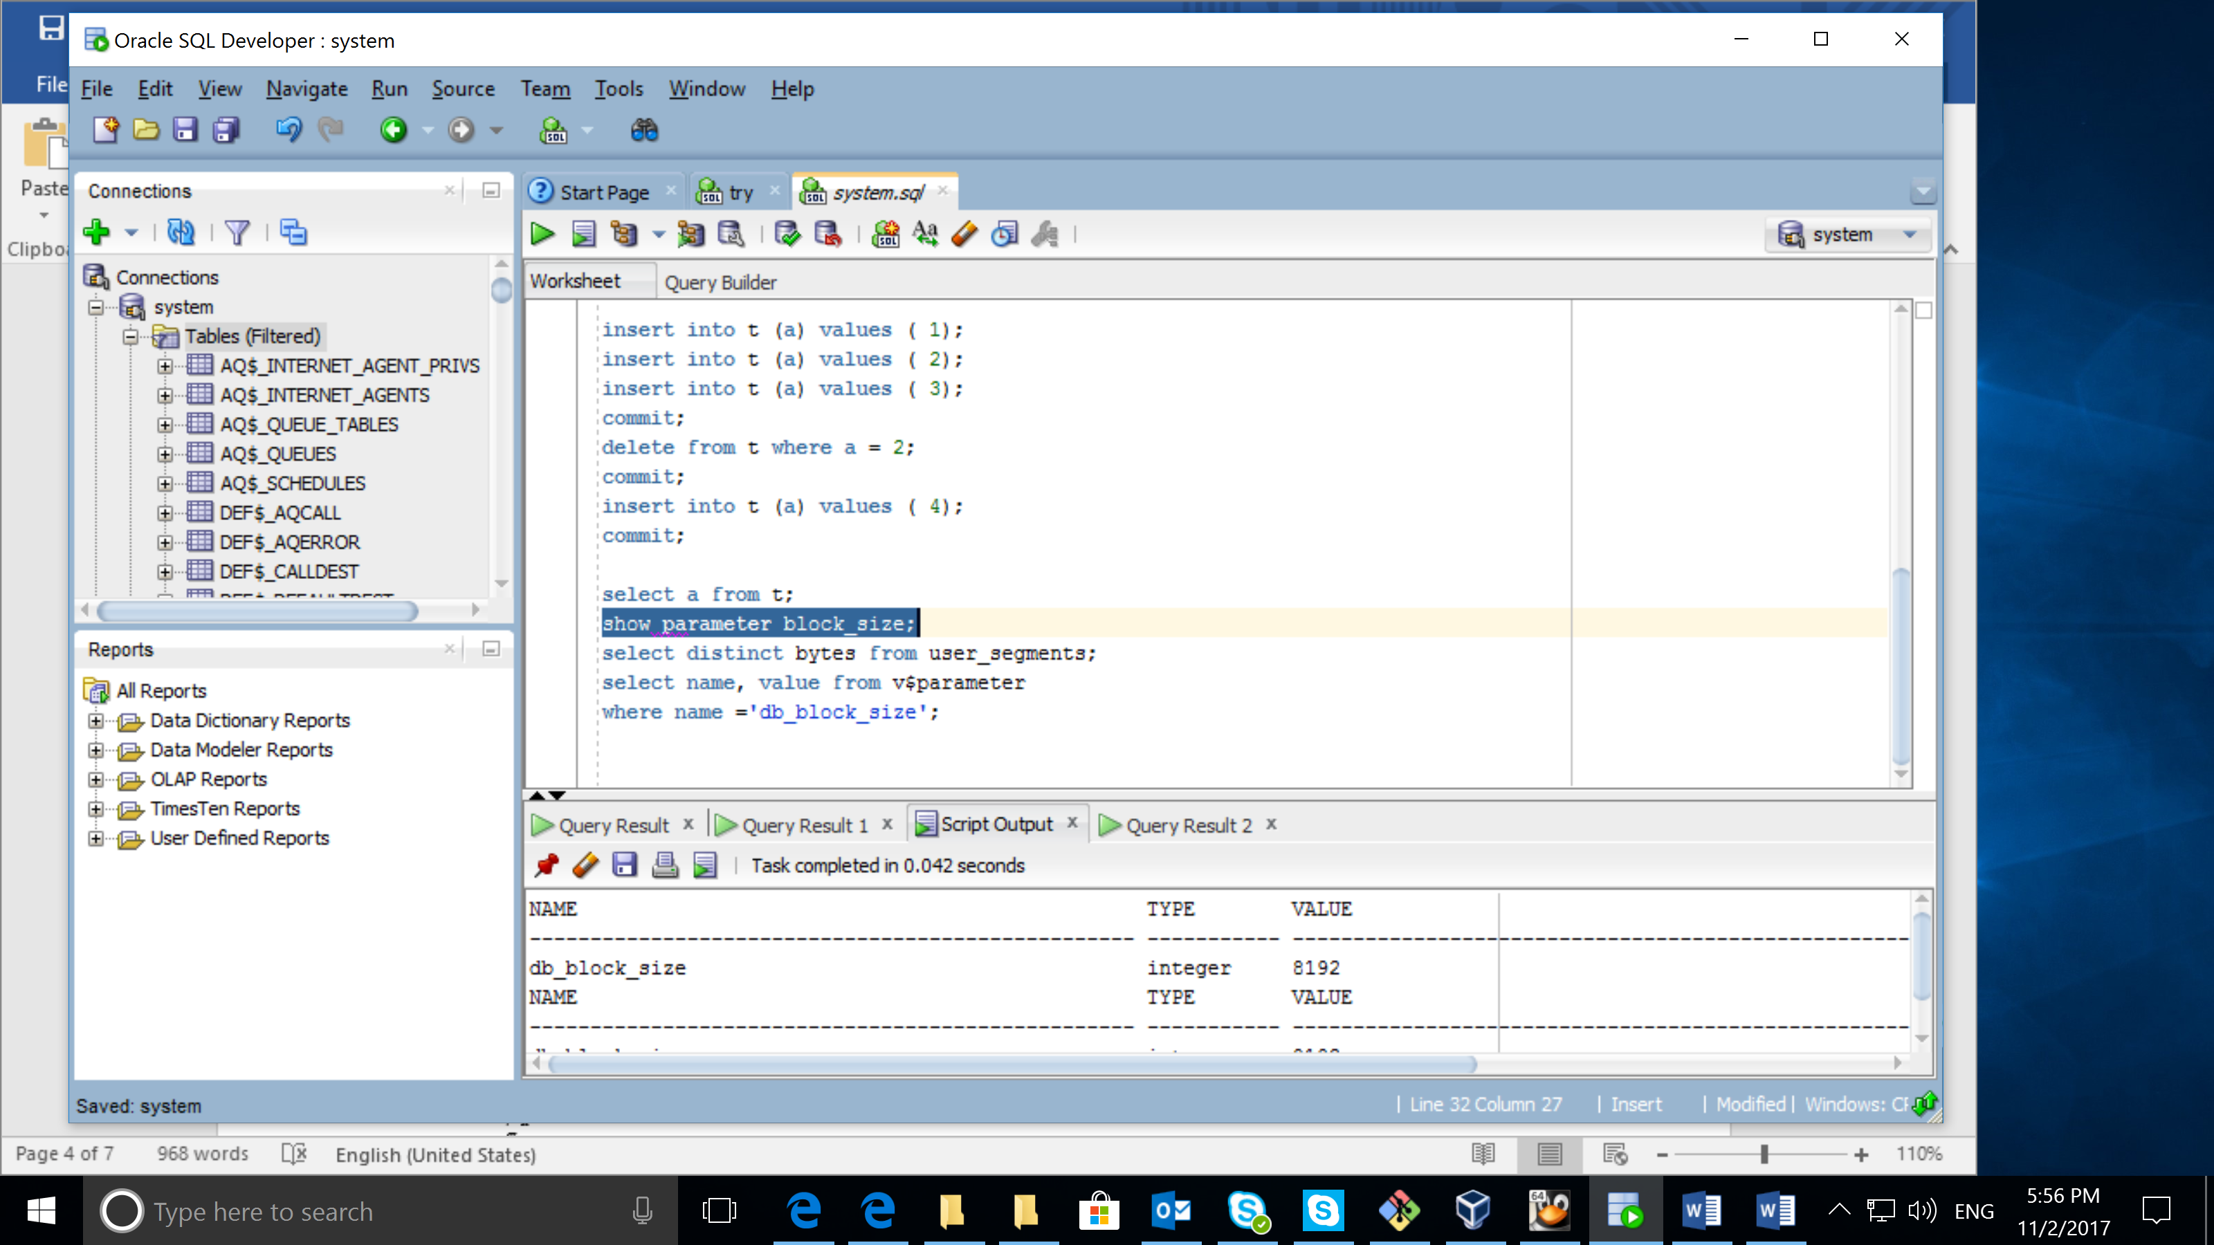

select distinct bytes/blocks from user_segments;

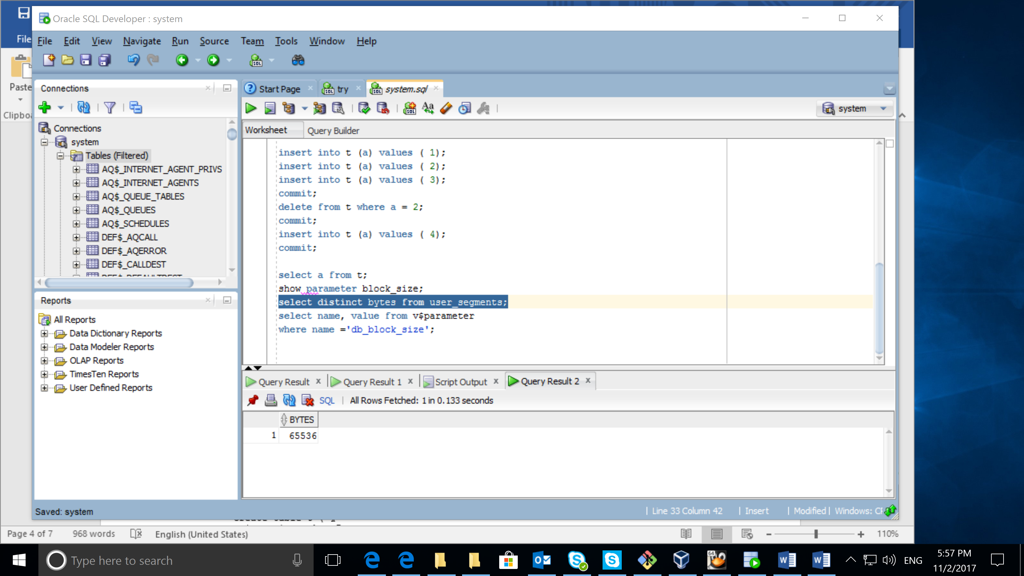

SELECT name,value

FROM v$parameter

WHERE name = 'db_block_size';

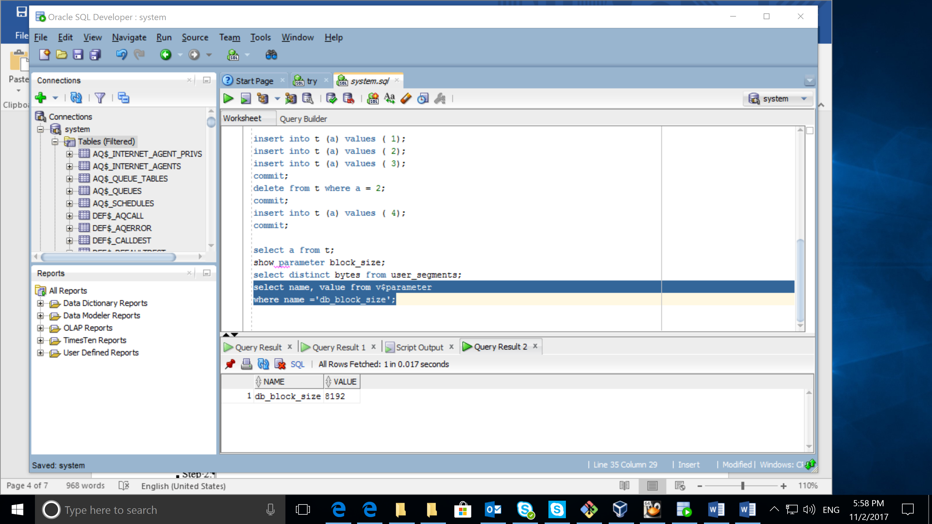

From the screens below we could see, that each record in the table is contained in one block. And when the record was deleted another record was added on that place, as the table is heap organized.

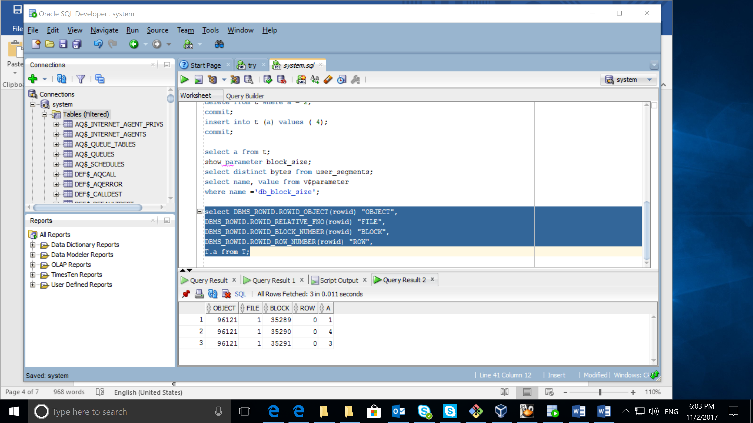

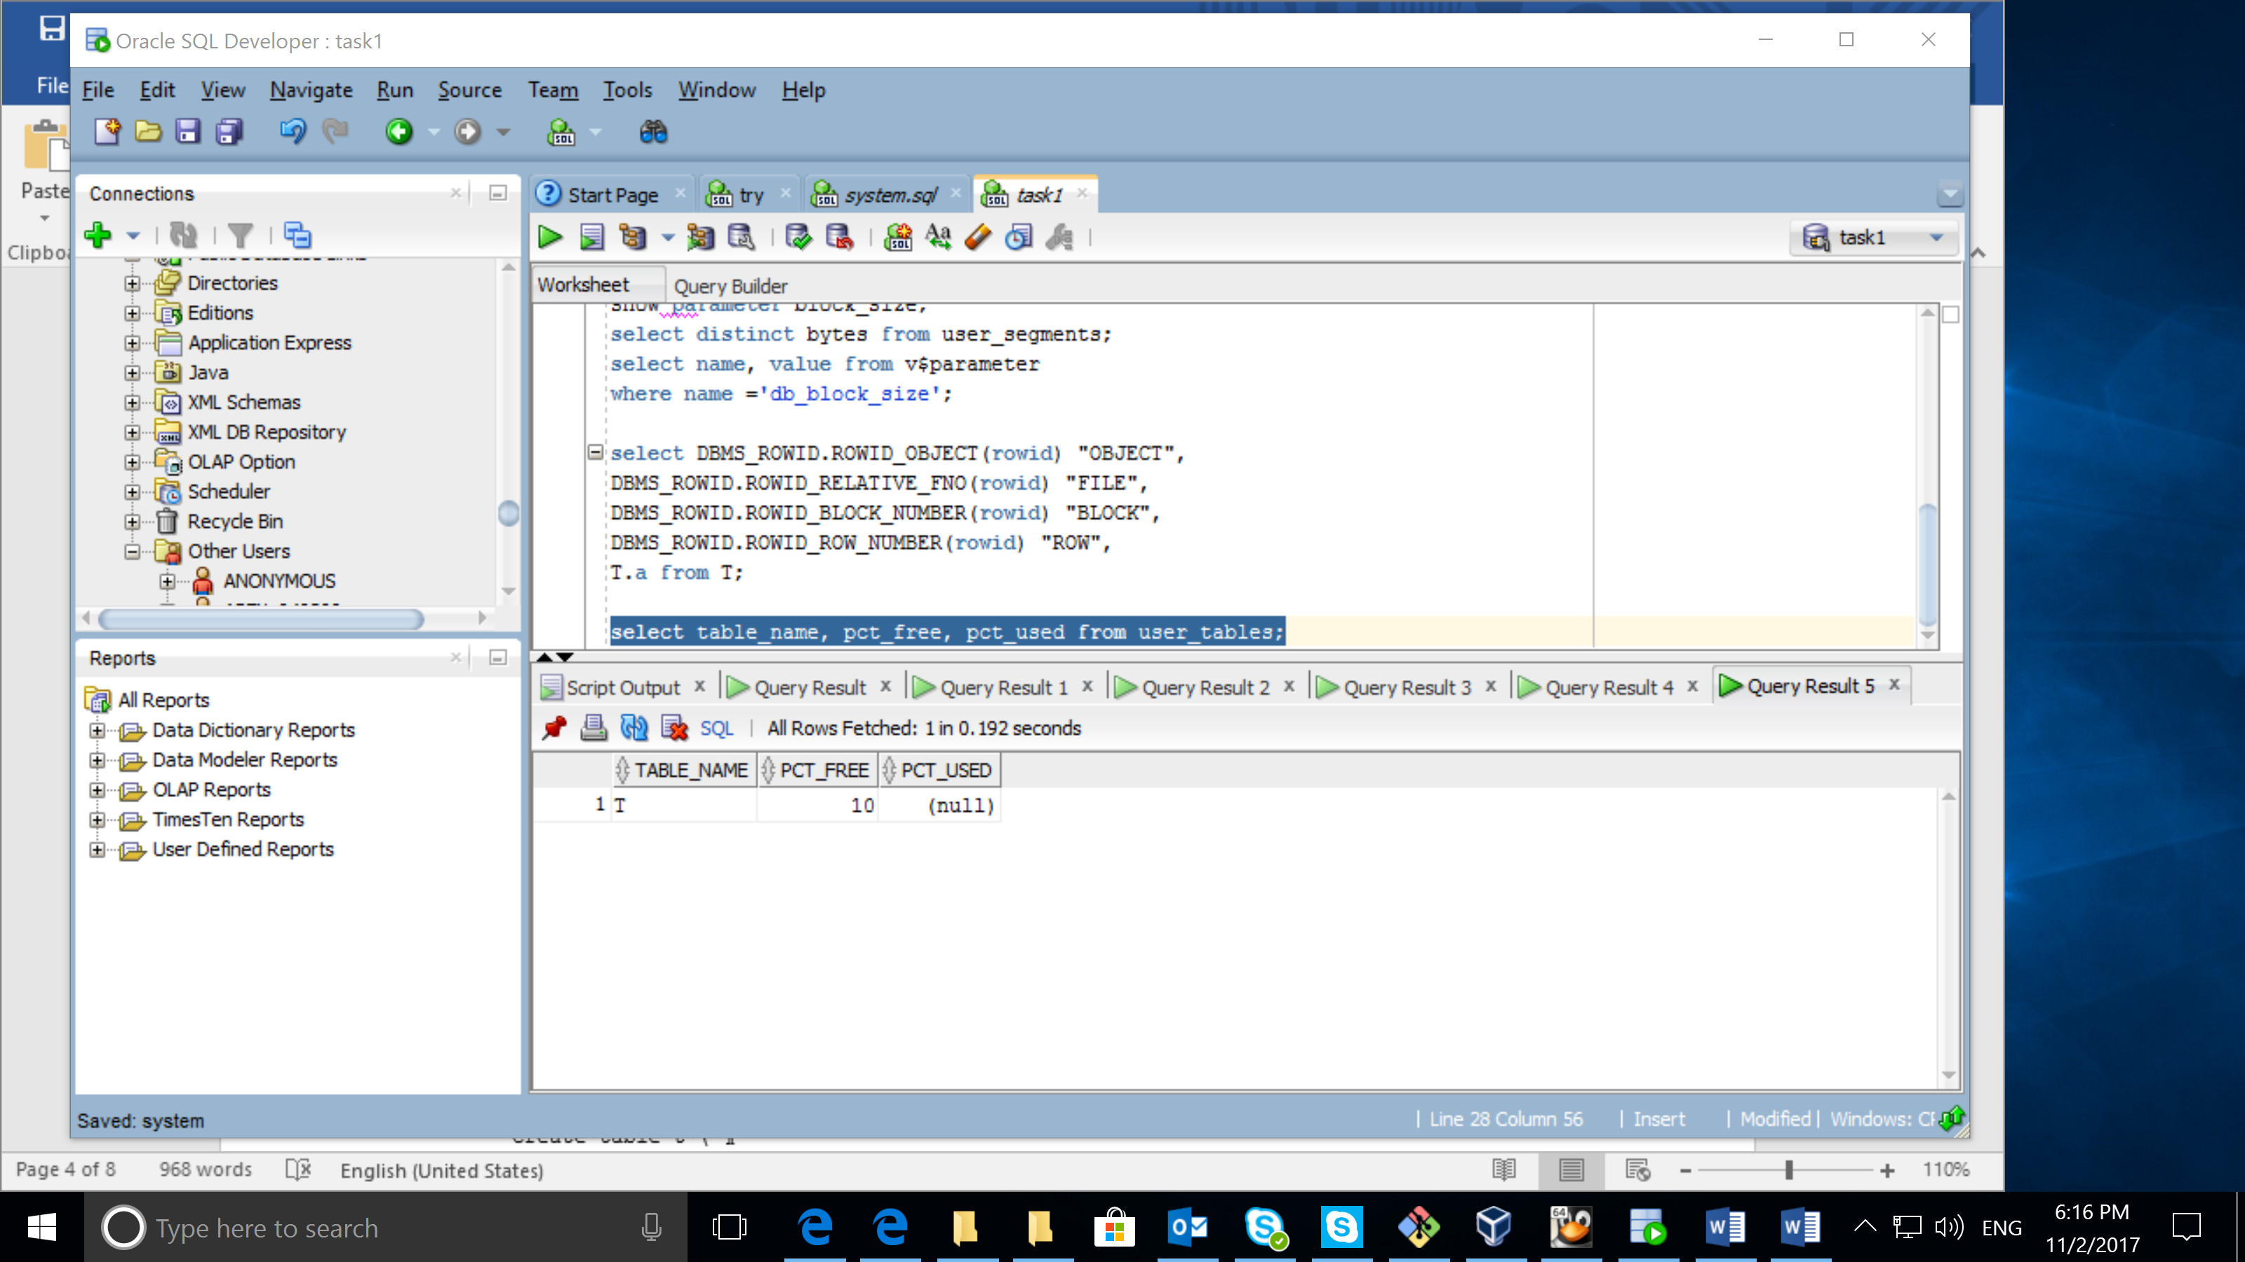

## Task 2 – Understanding Heap Table Segments

select segment_name, segment_type from user_segments;

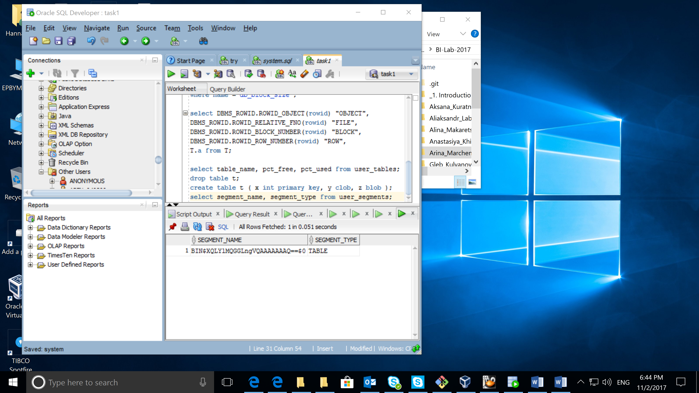

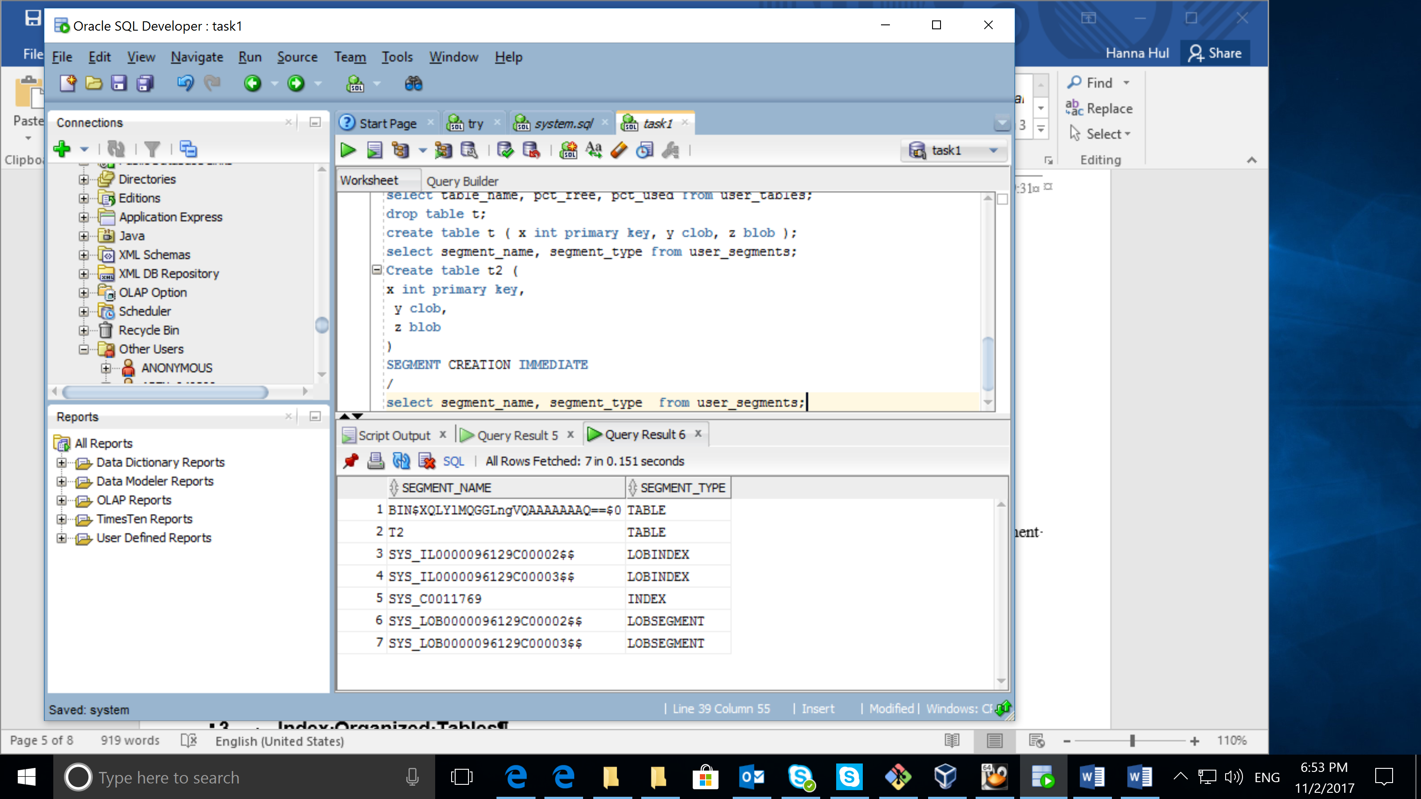

The screenshots show the difference between default behavior and segment creation immediate. By default the associated segments are not created until rows are inserted into the table. But if segment creation is defined, such segments are created immediately.

# Index Organized Tables

## Task 3: Compare performance

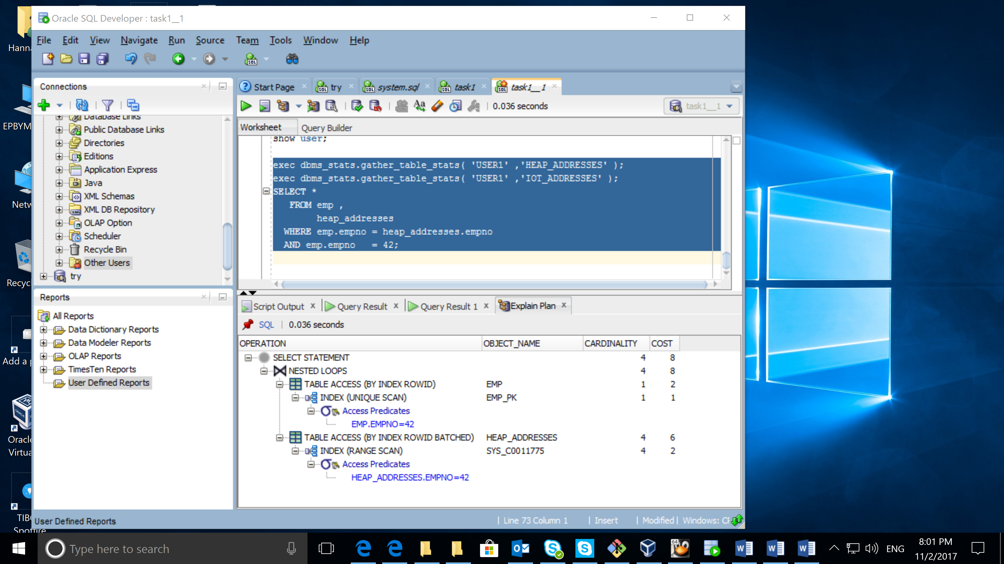

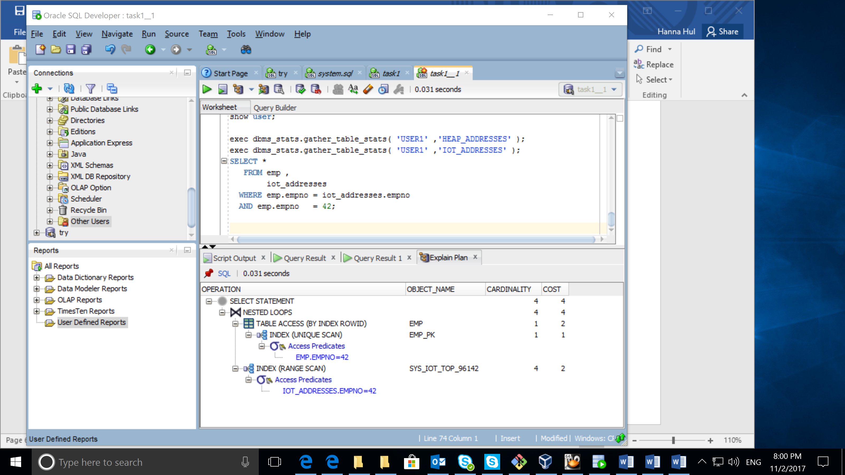

Compare results and explain Cost value calculation and difference on execution plan.

As index-organized tables are stored in an index structure, their physical order is based on the rows themselves. So in index-organized tables (IOTs) the data is stored in sorted order, according to the primary key.: The advantages of index-organized vs heap tables you could see on the execution plan above.

# Index Clustered Tables

## Task 4: Cluster Storage by Blocks

SELECT *

FROM

(

SELECT dept_blk, emp_blk, CASE WHEN dept_blk <> emp_blk THEN '*' END flag, deptno

FROM

(

SELECT dbms_rowid.rowid_block_number( dept.rowid ) dept_blk, dbms_rowid.rowid_block_number( emp.rowid ) emp_blk, dept.deptno

FROM emp , dept

WHERE emp.deptno = dept.deptno

)

)

ORDER BY deptno

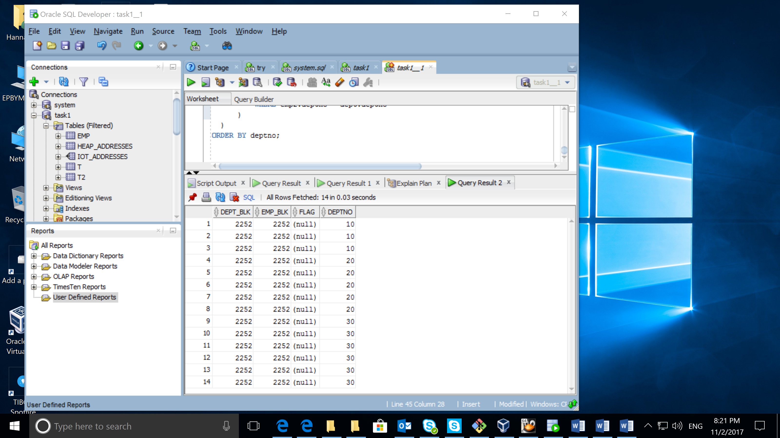

Clusters are groups of one or more tables, physically stored on the same database blocks, with all rows that share a common cluster key value being stored physically near each other. Normally, you would expect data from only one table to be found on a database block, but with clustered tables, data from many tables may be stored on the same block as you could see on the screen above. All data that contains the same cluster key value, such as DEPTNO = 10, will be physically stored together.

# Hash Clustered Tables

These tables are similar to index clustered tables, but instead of using a B*Tree index to locate the data by cluster key, the hash cluster hashes the key to the cluster to arrive at the database block the data should be on. With an indexed table or indexed cluster, Oracle Database locates table rows using key values stored in a separate index. Oracle Database applies the hash function to the cluster key value of the row. The resulting hash value corresponds to a data block in the cluster, which the database reads or writes on behalf of the issued statement. Hashing is an optional way of storing table data to improve the performance of data retrieval. In the picture you could see that blocks differ now.

# Row Migration

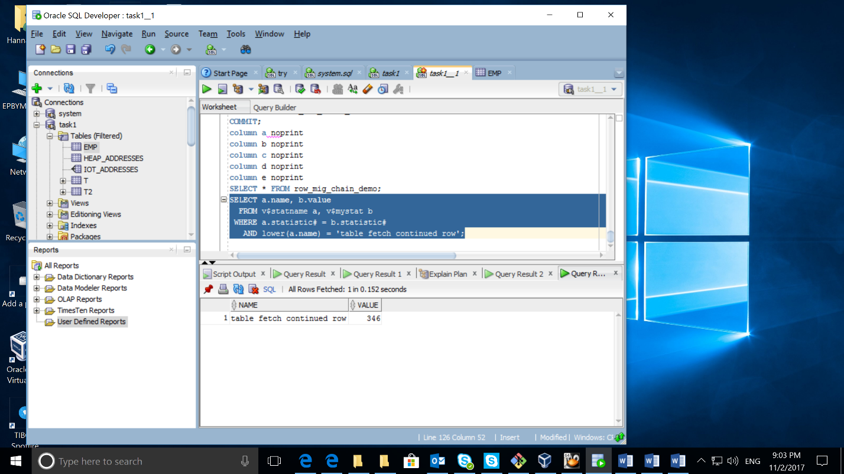If the row is too large to fit into a single database block the row chaining takes place. For example, if you use a 4KB blocksize for your database, and you need to insert a row of 8KB into it, Oracle will use 3 blocks and store the row in pieces. Some conditions that will cause row chaining are: Tables whose rowsize **exceeds** the blocksize. Tables with LONG and LONG RAW columns are prone to having chained rows. Tables with more then 255 columns will have chained rows as Oracle break wide tables up into pieces. So, instead of just having a forwarding address on one block and the data on another we have data on two or more blocks.

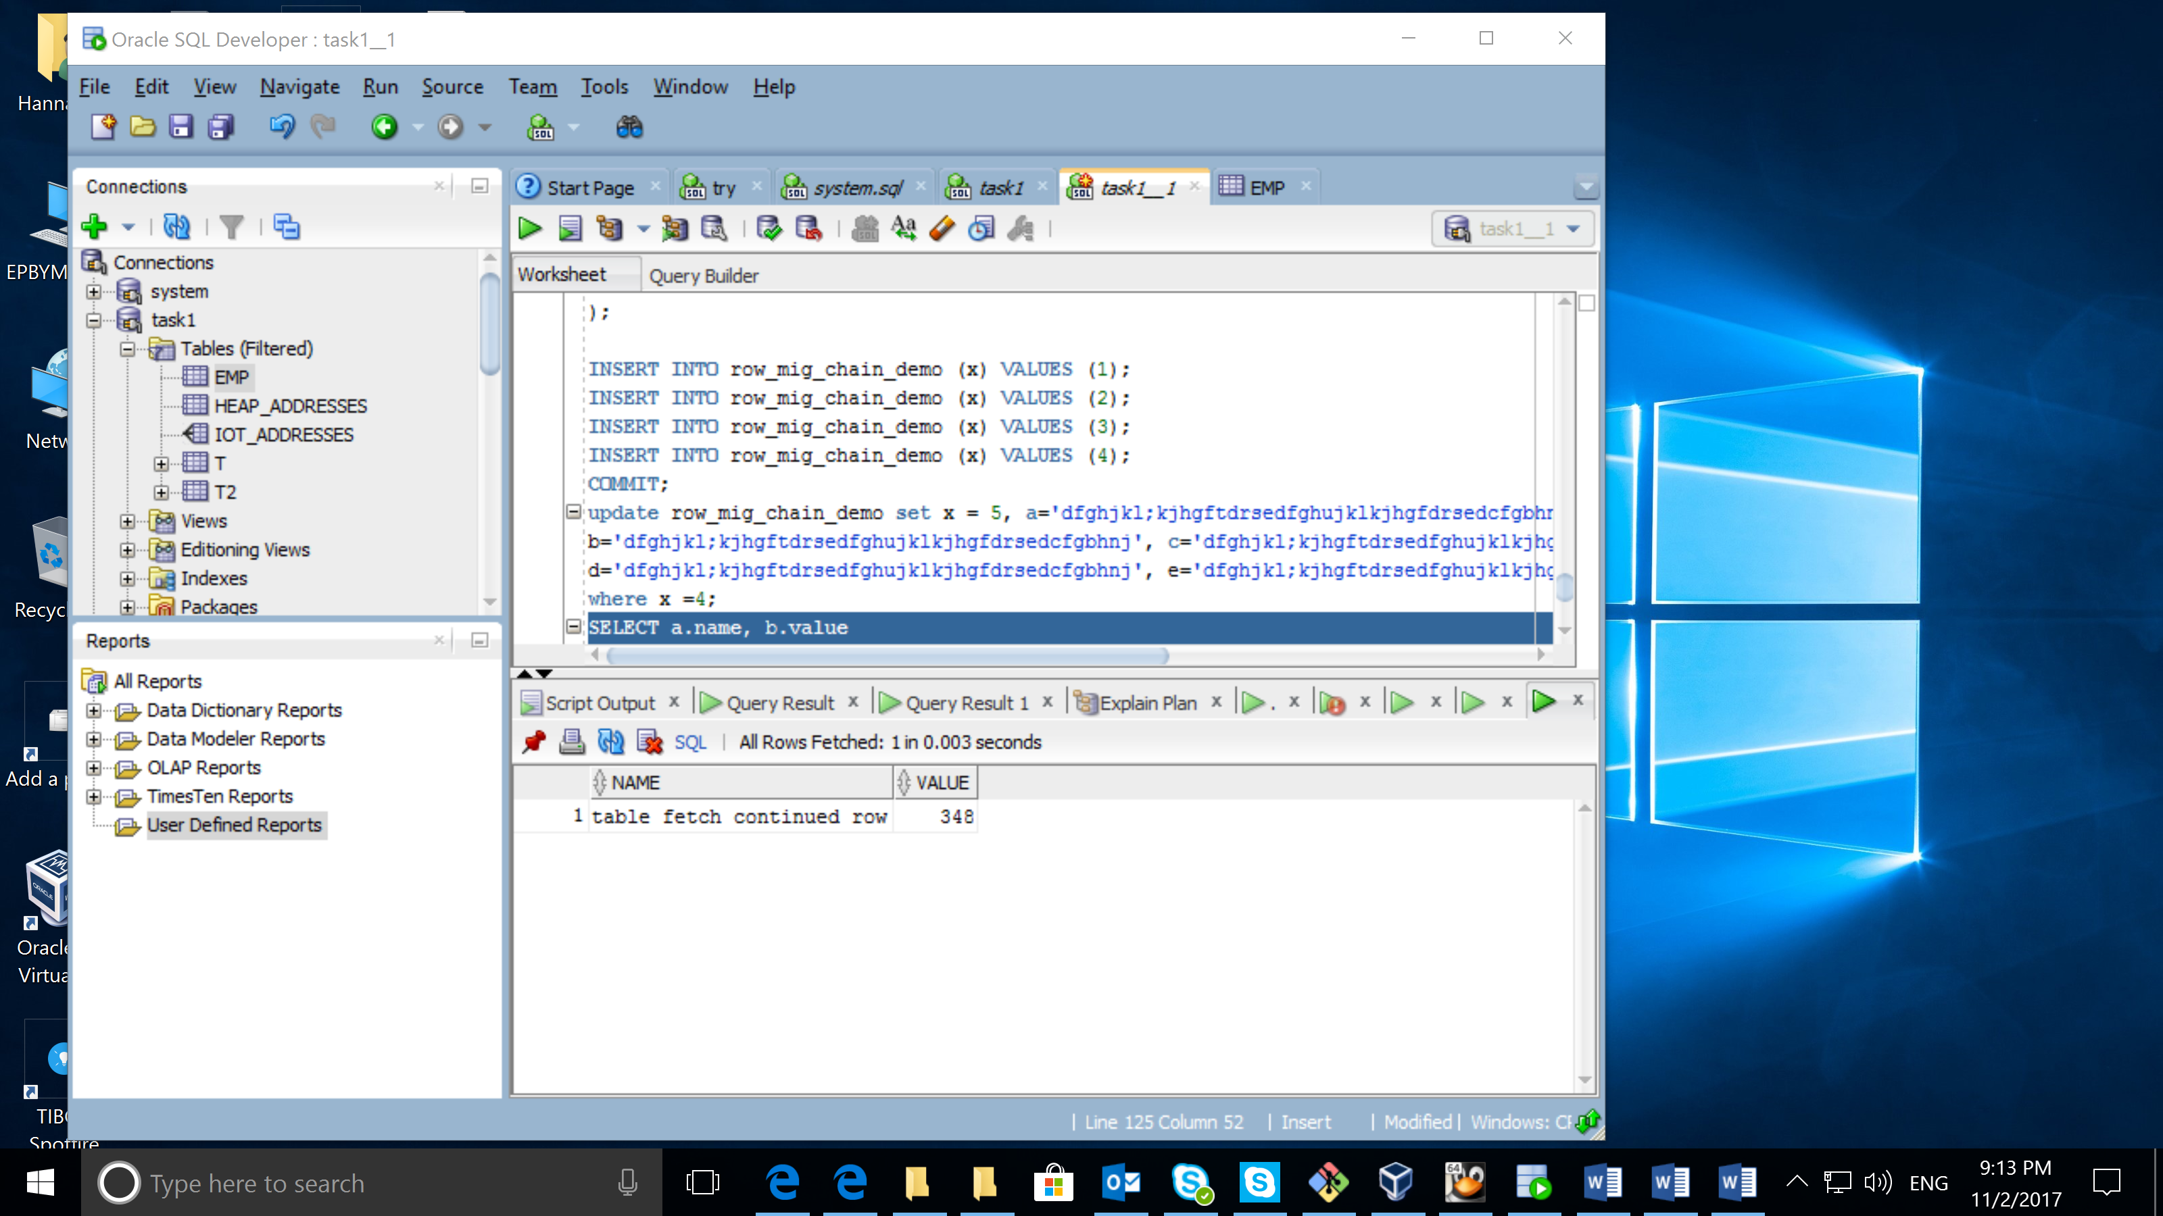Row migration happens with a row when an update to that row would cause it to not fit on the block anymore (with all of the other data that exists there currently).  A migration means that the entire row will move and we just leave behind the «forwarding address». So, the original block just has the rowid of the new block and the entire row is moved